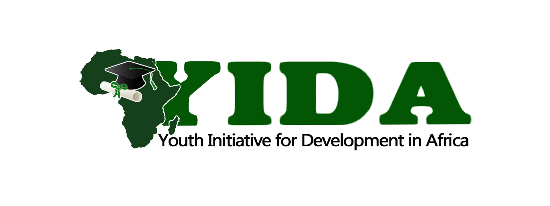
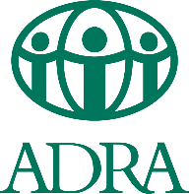
CHILD SPONSORSHIP AGREEMENT

This agreement is concluded between the following parties:

The Implementing Organization: YIDA Youth Initiative
Adress: Kyaka II Refugee Settlement, Kyegegwa
E-mail: james@youthinitiativefda.org
Organization Registration number: REGR164065790NB
and
Sponsored family and students, see the attached list of which is below

It is agreed as follows:
- The Implementing organization in cooperation with The Donors Organization undertakes:
  - Provide education to the sponsored student within the agreed scope.
  - Provide school supplies, aids and school uniform
  - Ensure regular meals for the student
  - Regularly inform parents and sponsors about the student's education and, in case of problems, inform them in time and look for a solution together.
  - The sponsor and parents shall have the right to access the child's/children's performance report
  - The financial gift is to be used exclusively for the financial support of the above-mentioned student's education
  - In the case that the student ends his education for any reason, the school undertakes to return the remaining funds to the sponsor.
  - The school undertakes to use the sponsorship exclusively to cover the following costs:
    - School fees
    - School uniform
    - School lunches
- The parents/guardian of the sponsored student undertakes:
  - Ensure that the student systematically attends school and properly fulfills school duties
  - Agree that school will submit reports to the sponsor about the student's progress and the progress of his educational process
  - They expressly agree to the use of photographs of the children, their names and a description of their family situation by the sponsor
- In case of sickness the school shall be limited to first aid, the parent/guardian shall be responsible for medical bills
- The parties to this agreement undertake to jointly agree on any further conditions and changes in order to fulfill the goal - ensuring education for the student.
- In agreement of the above terms and conditions all parties append their signatures here below.

In Kyaka II: 01/01/2025

YIDA Youth Initiative:
Represented by the director: James Gihoma Ntakiruti

Siganture and stamp:

List of sponsored families: (signed by parent / guardian)

No: | Name of parent / guardian: | Name of student: | Date of birth: | Signature:

